***PROJECT OF MYSQL E-COMMERCE SALES***

1. **List all customers from the USA, ordered by name:**

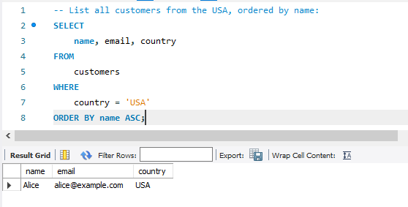

1. **Total quantity sold per product:**

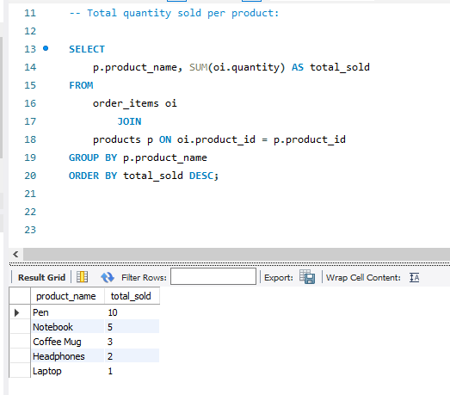

1. **Show all orders with customer name and order date (Inner Joins):**

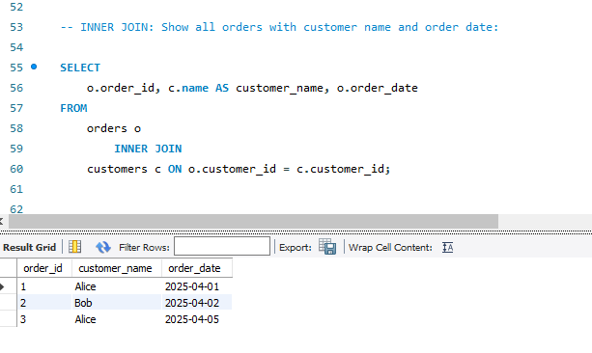

1. **Show all customers and their orders (Left Joins):**

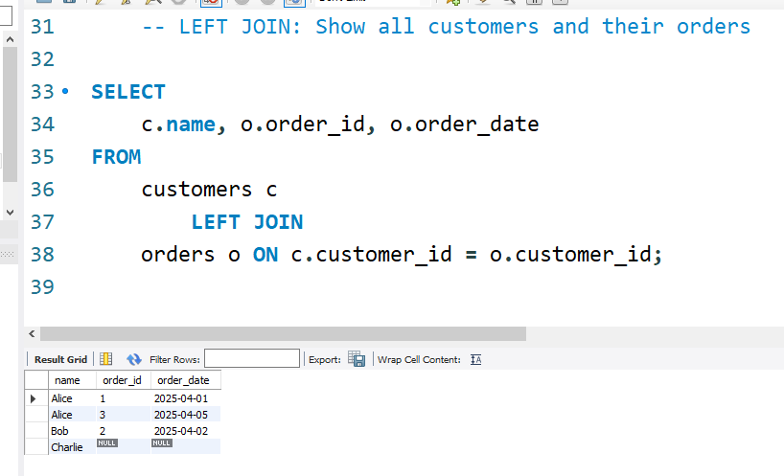

1. **Show all orders and customer info (Right Joins):**

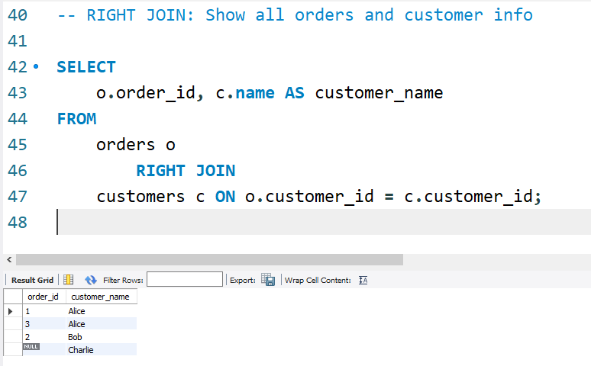

1. **Find customers who placed more than 1 order (SUB-QUERIES):**

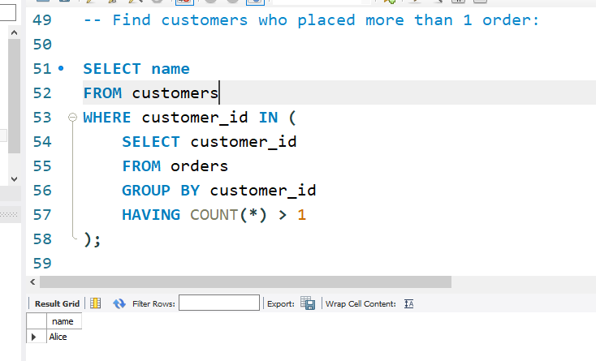

1. **Total revenue per category (SUM, AVG):**

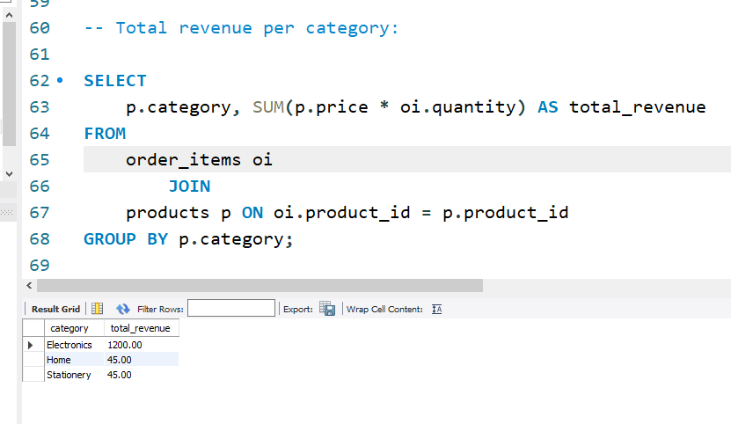

1. **Create a view for top-selling products (CREATING VIEW):**

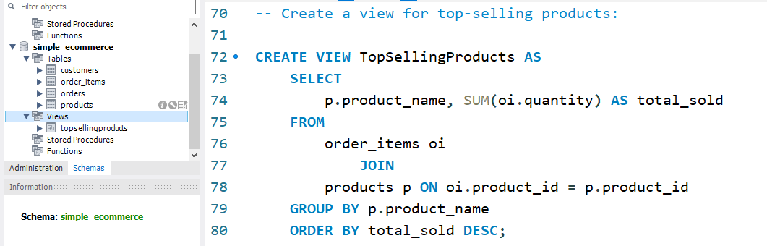

1. **Add index on customer-id and order-date for faster search (ADDING INDEX):**

